Year 1 Home Learning Timetable Summer 2 Week 6

Day | Get Active at Home | English | Maths | Topic
Monday | 9am Joe Wicks Workout https://www.youtube.com/user/thebodycoach1  Mindfulness Children’s yoga videos www.youtube.com/user/CosmicKidsYoga | Reading - choose one of your reading books and read to an adult for 10 minutes OR log on to Oxford Owl and read some of the ebooks. Please create your own login!  Free eBook library  Activity:  WALT read the a-e digraph.  Espresso Ash’s phonics | Ten minutes - TTRS  Activity:  WALT tell the time to the half hour.  Education City.  Play Half Time Scores  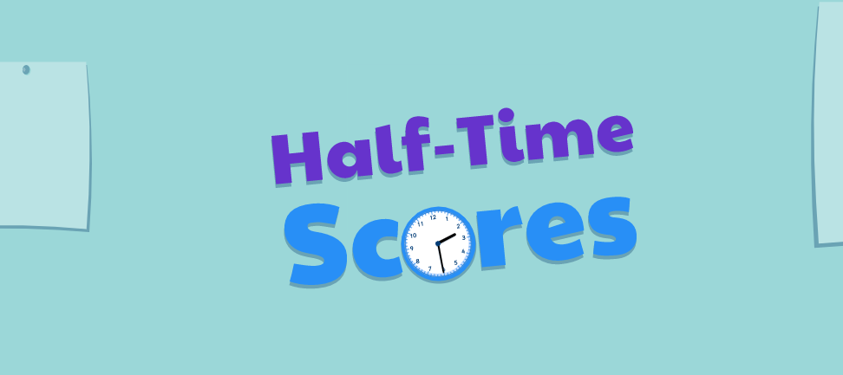 | Poetry  Espresso  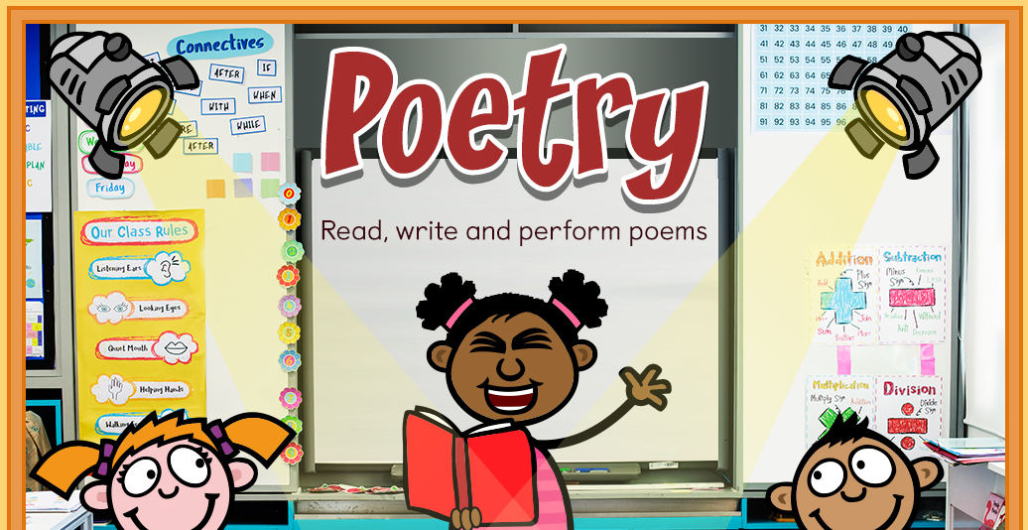  Choose 3 videos to watch:  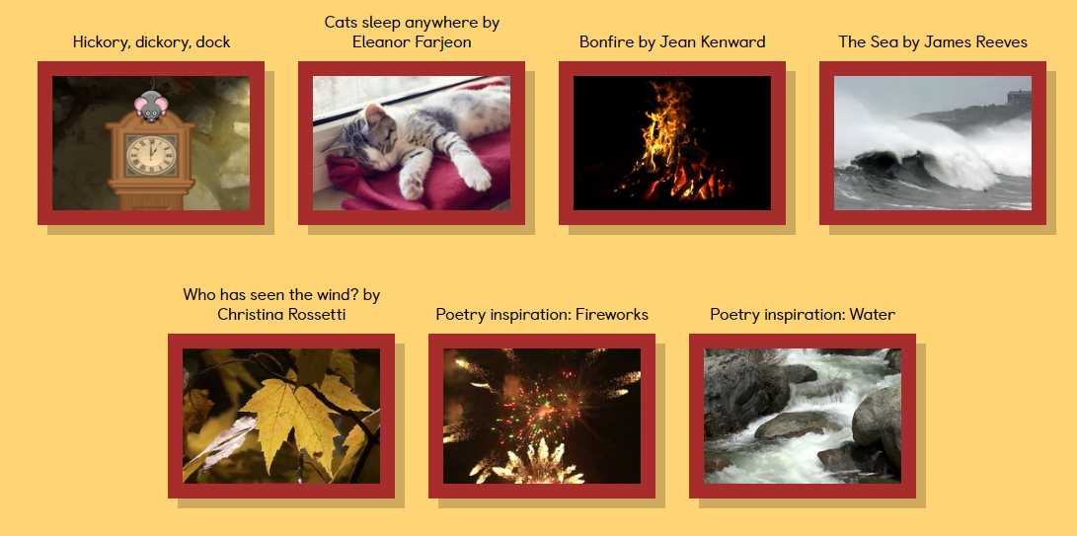  Have a go at the rhyming activities:  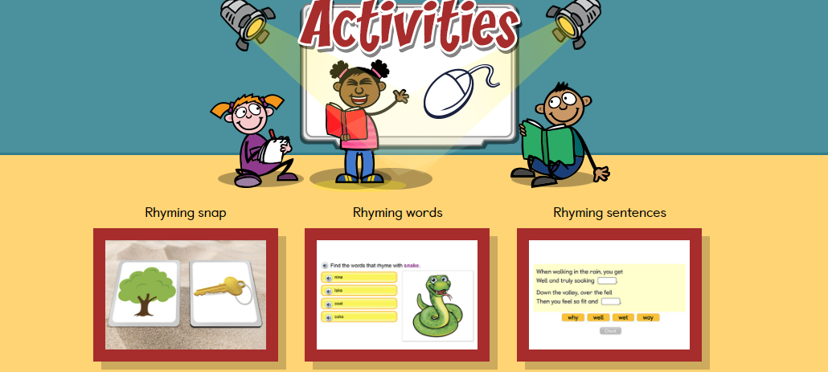  Have a go at writing your own poem.
Tuesday |  | Reading - choose one of your reading books and read to an adult for 10 minutes  OR log on to Oxford Owl and read some of the ebooks.https://www.oxfordowl.co.uk/for-home/find-a-book/library-page/  Activity:  WALT read the u-e digraph.  Espresso. Ash’s phonics  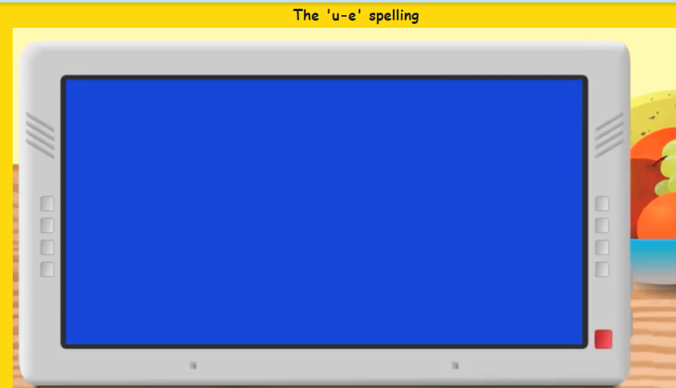 | Ten minutes -TTRS  Activity:  WALT tell the time to the half hour.  Espresso  - Home  - >  - Maths 1  - >  - Time  - >  - Activities  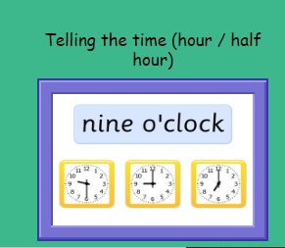 | Music  Espresso Musical Stories  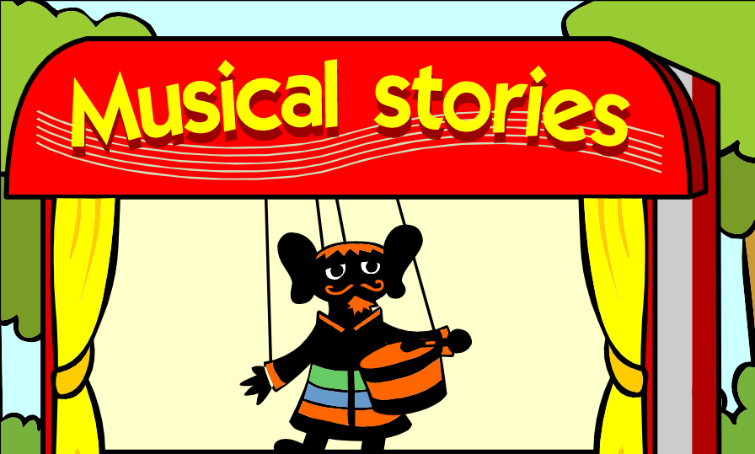  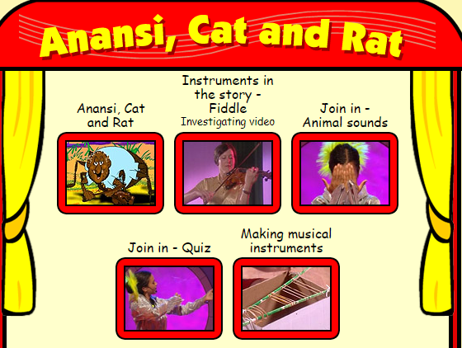  Explore sounds, rhythms and instruments through the animated stories
Wednesday |  | Reading - choose one of your reading books and read to an adult for 10 minutes  OR log on to Oxford Owl and read some of the ebooks.  https://www.oxfordowl.co.uk/for-home/find-a-book/library-page/  Activity:  WALT read the e_e digraph.  Espresso. Ash’s phonics | Ten minutes - Times table rock Stars  Activity:  WALT measure time.  Education City “Measuring Time”  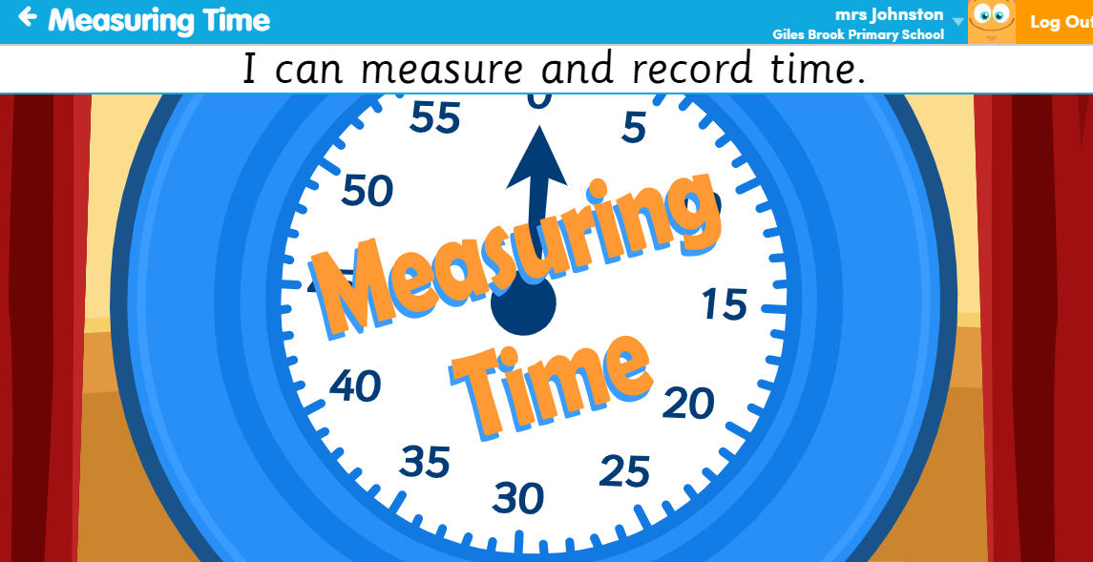 | Handwriting  Choose 5 tricky words. Can you practise spelling your words using the look, cover, write and check method.
Thursday |  | Reading - choose one of your reading books and read to an adult for 10 minutes  OR log on to Oxford Owl and read some of the ebooks.  https://www.oxfordowl.co.uk/for-home/find-a-book/library-page/  Activity:  WALT: read our high frequency/tricky words  Espresso-Sal’s Phonics.  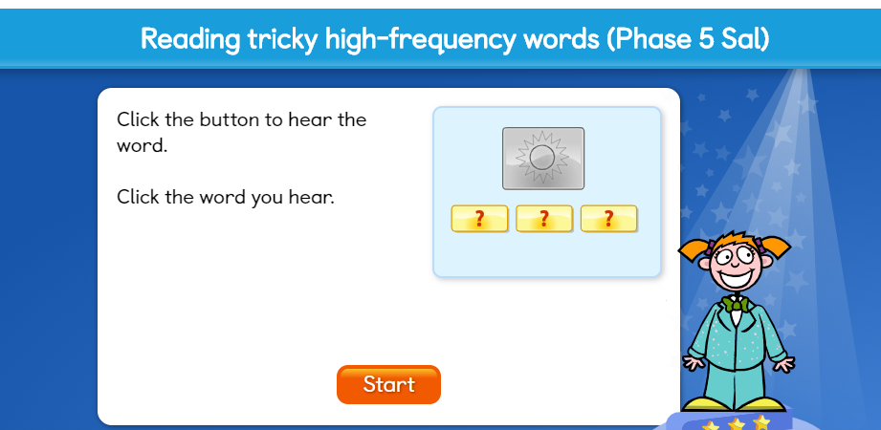 | Ten minutes - Times table rock Stars  Activity:  WALT compare measurements of time.  What can you do in 1 minute?  How many of the following can you do……...  Star jumps  Hops  Runs on the spot  Bounces of a ball  Now how many can you do in 2 minutes? Do you think it will be more or less? Is 2 minutes longer or shorter than 1 minute? | ICT- coding  Unit 1b ‘Obey my command’  Lesson 5 My own app (click and start) on Espresso coding (remember to log in to Google Chrome and link data first so that you don’t need to keep putting in your username and password each time).  Each step of the lesson has a help video for you to watch before you give it a go!  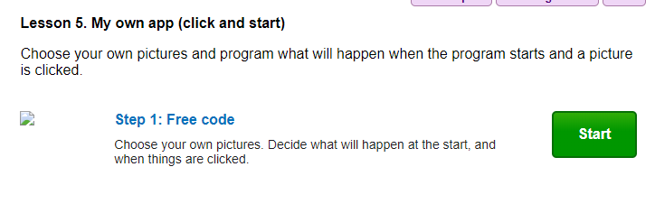
Friday |  | Reading - choose one of your reading books and read to an adult for 10 minutes  OR log on to Oxford Owl and read some of the ebooks.  https://www.oxfordowl.co.uk/for-home/find-a-book/library-page/  Activity:  Phonics -  WALT:Spell high frequency/tricky words  Espresso Sal’s phonics  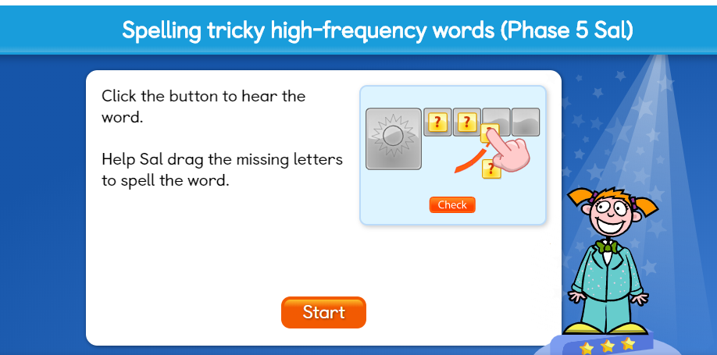 | Ten minutes - TTRS  Activity:  WALT compare measurements of time.  Eduction City-Measuring Time  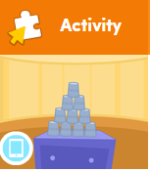  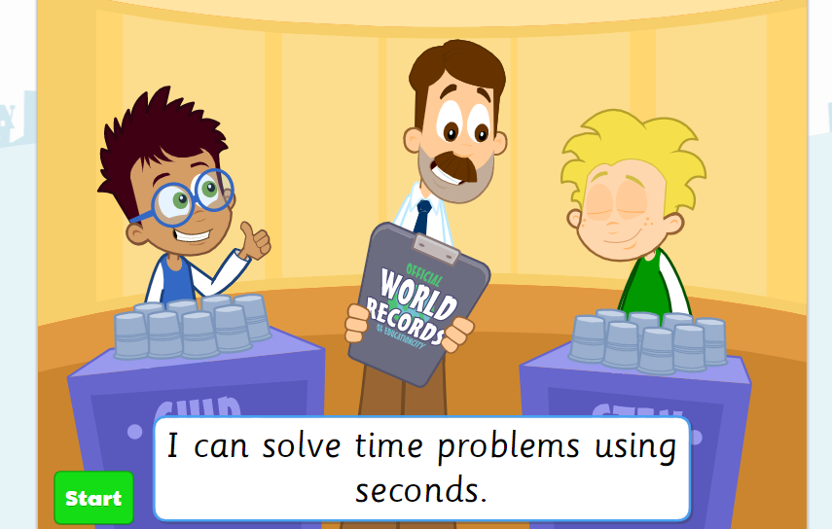 | PSHE  Talk to an adult about what makes you special? What makes you a good friend? What makes you feel proud of yourself?  Make a poster all about yourself. Make it colourful and eye catching.

