Year 1 Home Learning Timetable Summer 2 Week 5

Day | Get Active at Home | English | Maths | Topic
Monday | 9am Joe Wicks Workout https://www.youtube.com/user/thebodycoach1  Mindfulness Children’s yoga videos www.youtube.com/user/CosmicKidsYoga | Reading - choose one of your reading books and read to an adult for 10 minutes OR log on to Oxford Owl and read some of the ebooks. Please create your own login!  Free eBook library  Activity:  WALT read the au digraph.  Espresso Ash’s phonics  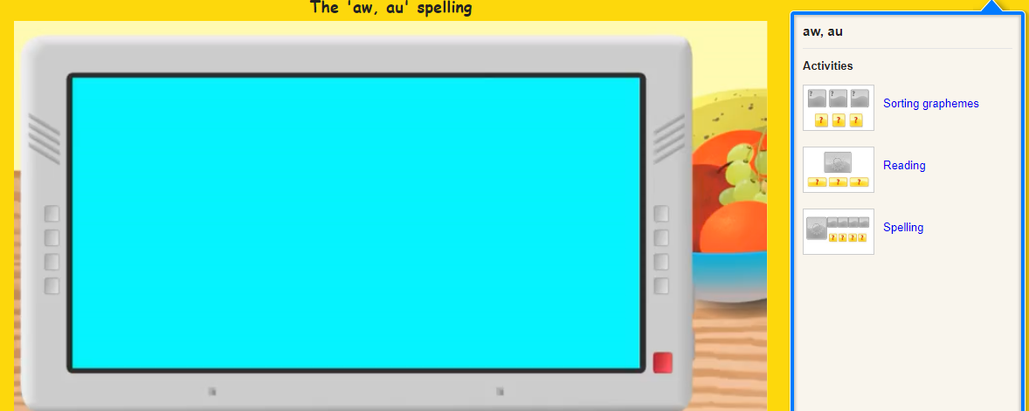 | Ten minutes - TTRS  Activity:  WALT use vocabulary related to time  With an adult, talk though what you do in a day. Try to use the language “first” “next” “In the morning” “In the afternoon”  Which activities do you do before school?  Which activities do you do after school?  What do you do in the morning?  What do you do in the afternoon?  What do you do in the evening? | Lay down in a space with your eyes closed. Ask an adult to put on some relaxing music of the waves on a beach. Perhaps seagulls squawking overhead. Think about what you can hear, see, smell, taste, feel. Ask an adult to write down all of your ideas on a sheet of paper.  Using your ideas. Have a go at writing a sense poem.  I can see……  I can smell…..  I can taste…..  I can hear……  I can feel…….
Tuesday |  | Reading - choose one of your reading books and read to an adult for 10 minutes  OR log on to Oxford Owl and read some of the ebooks.https://www.oxfordowl.co.uk/for-home/find-a-book/library-page/  Activity:  WALT read the ey digraph.  Espresso. Ash’s phonics  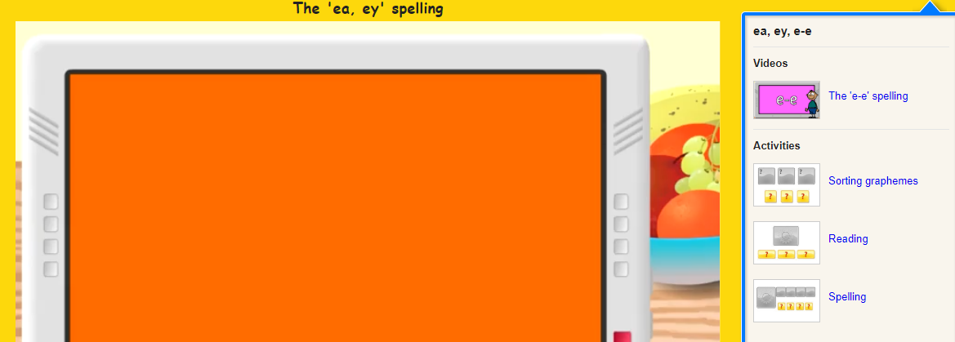 | Ten minutes - TTRS  Activity:  WAL the days of the week.  Espresso  - Home  - >  - Maths 1  - >  - Time  - >  - Videos  Watch:  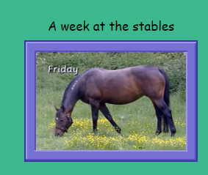  Have a go at this activity:  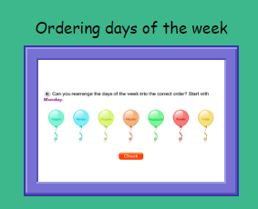 | Art  Have a go at completing a seaside themed craft activity.  Hermit Crab:  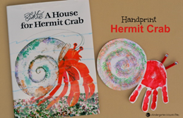  Seaside pebble painting:  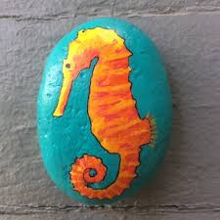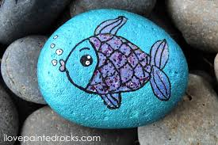  Paper plate Jellyfish:  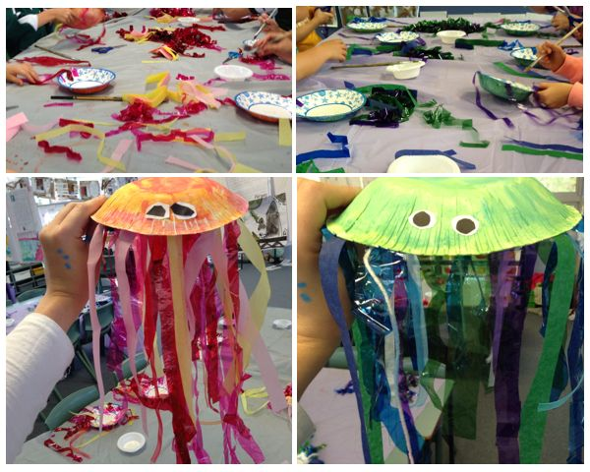  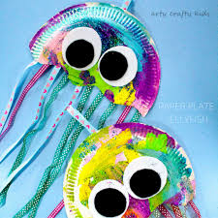
Wednesday |  | Reading - choose one of your reading books and read to an adult for 10 minutes  OR log on to Oxford Owl and read some of the ebooks.  https://www.oxfordowl.co.uk/for-home/find-a-book/library-page/  Activity:  WALT read the i_e digraph.  Espresso. Ash’s phonics  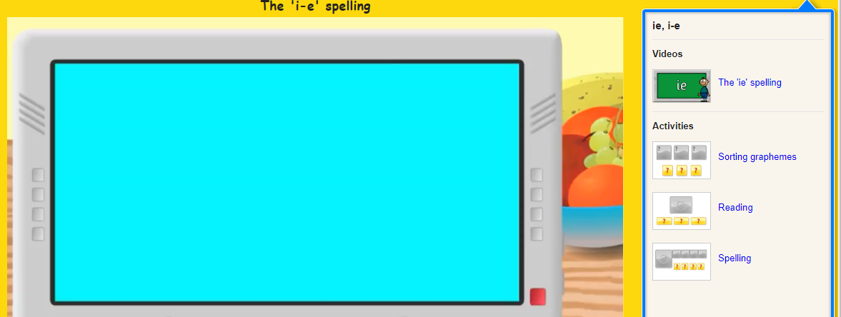 | Ten minutes - Times table rock Stars  Activity:  WAL the days of the week.  Education City  Play “Sten’s Week”  Recognise and use language relating to the days of the week.  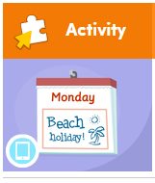 | Handwriting  Choose 5 tricky words. Can you practise spelling your words using the look, cover, write and check method.
Thursday |  | Reading - choose one of your reading books and read to an adult for 10 minutes  OR log on to Oxford Owl and read some of the ebooks.  https://www.oxfordowl.co.uk/for-home/find-a-book/library-page/  Activity:  WALT read the o_e digraph.  Espresso. Ash’s phonics  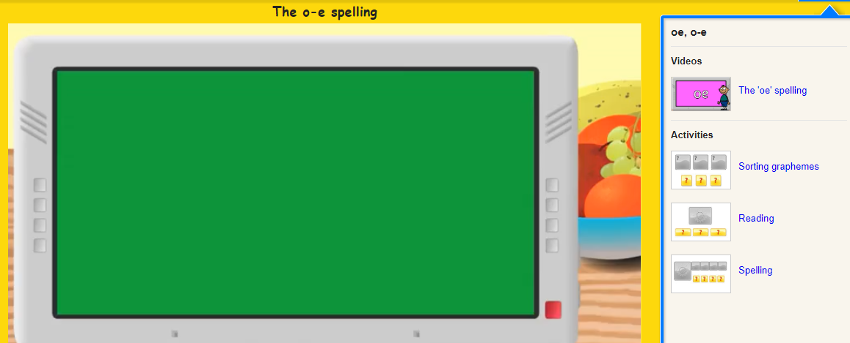 | Ten minutes - Times table rock Stars  Activity:  WALT tell the time to the hour.  Education City “Tick Tock”  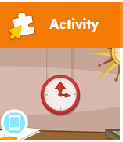  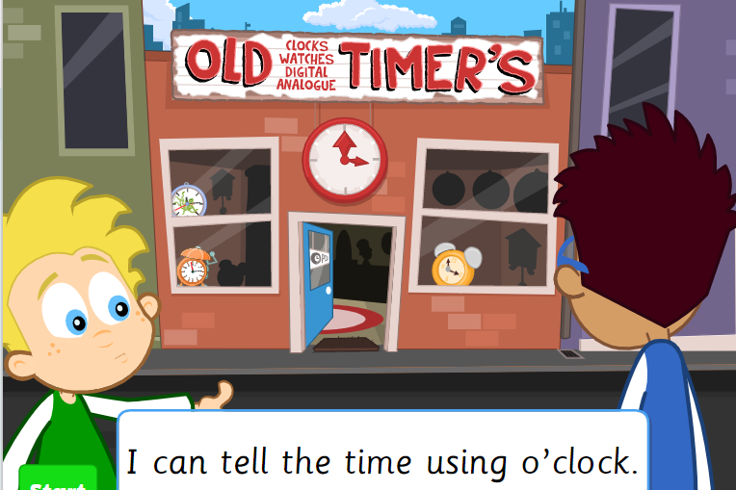 | ICT- coding  Unit 1b ‘Obey my command’  Lesson 4 Emergency on Espresso coding (remember to log in to Google Chrome and link data first so that you don’t need to keep putting in your username and password each time).  Each step of the lesson has a help video for you to watch before you give it a go!  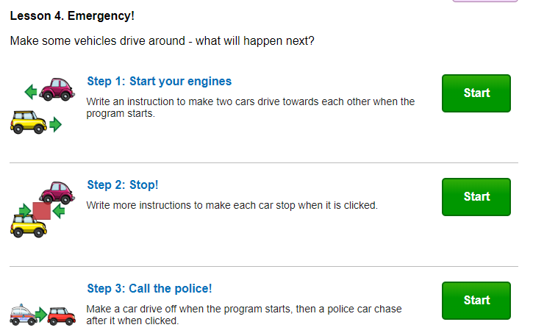
Friday |  | Reading - choose one of your reading books and read to an adult for 10 minutes  OR log on to Oxford Owl and read some of the ebooks.  https://www.oxfordowl.co.uk/for-home/find-a-book/library-page/  Activity:  Phonics -  Phonics play  Phase 5 “Tricky Trucks”  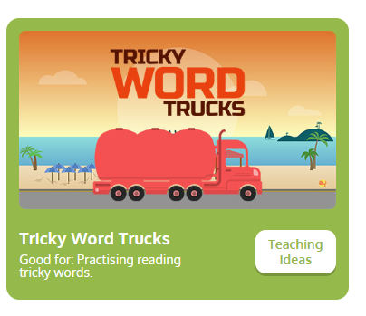 | Ten minutes - TTRS  Activity:  WALT tell the time  Espresso  - Home  - >  - Maths 1  - >  - Time  - >  - Videos  Watch:  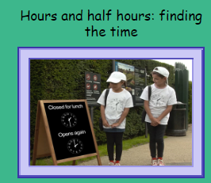  Have a go at playing:  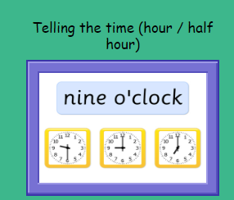 | PSHE  Espresso “Coping with change”  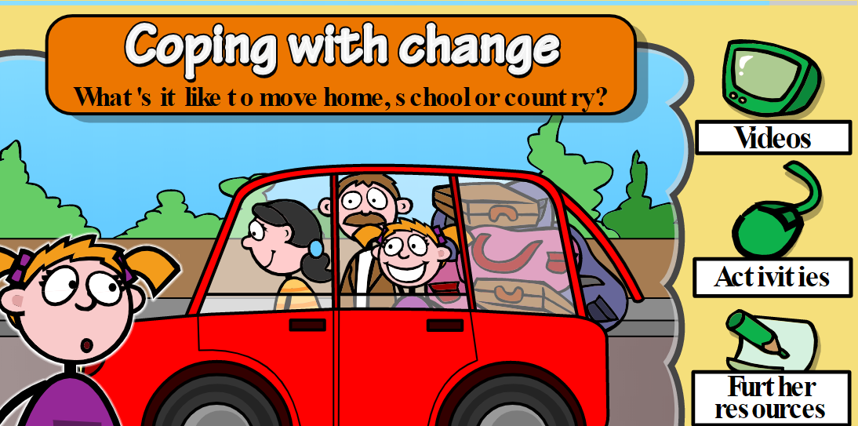  Watch the videos:  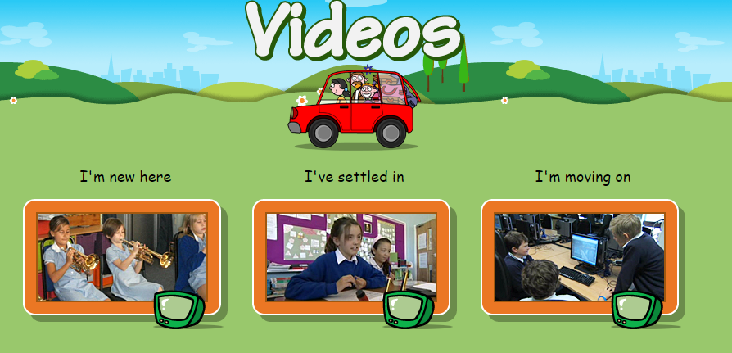  Complete the activity:  