Year 1 Home Learning Timetable Summer 2 Week 4

Day | Get Active at Home | English | Maths | Topic
Monday | 9am Joe Wicks Workout https://www.youtube.com/user/thebodycoach1  Mindfulness Children’s yoga videos www.youtube.com/user/CosmicKidsYoga | Reading - choose one of your reading books and read to an adult for 10 minutes OR log on to Oxford Owl and read some of the ebooks. Please create your own login!  Free eBook library  Activity:Education City  “Park and Read”  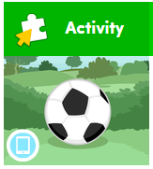  Have a go at predicting what might happen next. | Ten minutes - Number Bonds On Numbots  Activity:  WALT recognise coins  Play Dino Day Out on Education City.  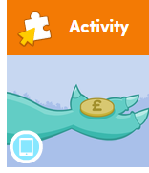 | WALT create a ‘what I’m looking forward to jar/ bag’  Discuss together the things we like to do/ see that we might not be able to do at the moment (focus on the positive of these experiences).  e.g. go the beach, visit grandma, eat at a restaurant, play in the park etc.  Write down on pieces of paper all of the things you are looking forward to doing. Put all of these pieces of paper in a jar/cup/bag. Once we are able to get back to some sort of normaily. Take a piece of paper out of the jar/cup/bag each weekend/once a month and do what it says :-)
Tuesday |  | Reading - choose one of your reading books and read to an adult for 10 minutes  OR log on to Oxford Owl and read some of the ebooks.https://www.oxfordowl.co.uk/for-home/find-a-book/library-page/  Activity:  Education City  “A Day in the Park”  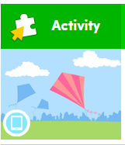  Read the extracts and answer the questions. | Ten minutes - Number Bonds On Numbots  Activity:  WALT recognise notes  Play Dinosaur of Notes on Education City.  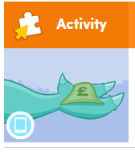 | Science  Education City  “Grow a Plant”  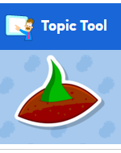
Wednesday |  | Reading - choose one of your reading books and read to an adult for 10 minutes  OR log on to Oxford Owl and read some of the ebooks.  https://www.oxfordowl.co.uk/for-home/find-a-book/library-page/  Activity:  Phonics - Education City  Space Adventure  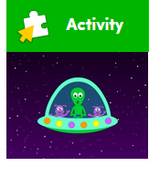  Practise reading CVCC words | Ten minutes - Times table rock Stars  Activity:  WALT count coins  On Espresso watch  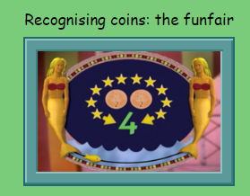  Have a go at playing  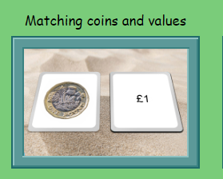 | Handwriting  Choose 5 tricky words. Can you practise spelling your words using the look, cover, write and check method.
Thursday |  | Reading - choose one of your reading books and read to an adult for 10 minutes  OR log on to Oxford Owl and read some of the ebooks.  https://www.oxfordowl.co.uk/for-home/find-a-book/library-page/  Activity:  Phonics - Education City  Rhyme and Space  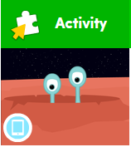  Match the words that rhyme | Ten minutes - Times table rock Stars  Activity:  WALT count coins and notes  Espresso  - Home  - >  - Maths 1  - >  - Money  - >  - Activities  - >  - Ordering combinations of coins and notes  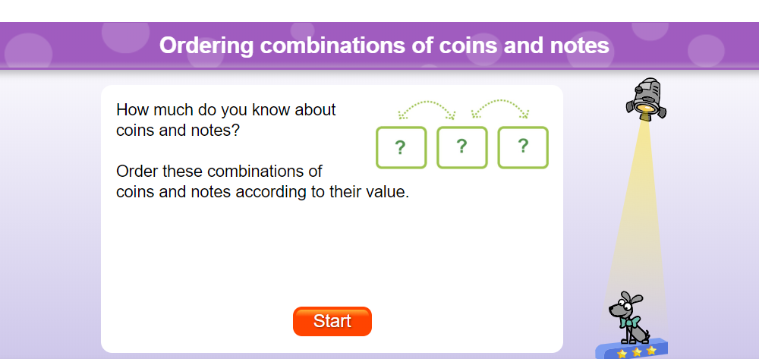 | ICT- coding  Unit 1b ‘Obey my command’  Lesson 3 The Magic Castle on Espresso coding (remember to log in to Google Chrome and link data first so that you don’t need to keep putting in your username and password each time).  Each step of the lesson has a help video for you to watch before you give it a go!  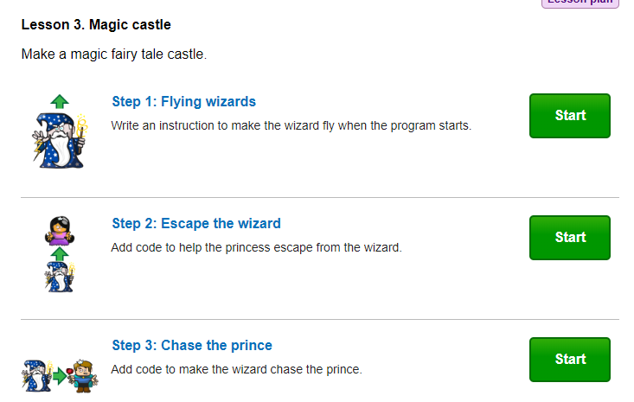
Friday |  | Reading - choose one of your reading books and read to an adult for 10 minutes  OR log on to Oxford Owl and read some of the ebooks.  https://www.oxfordowl.co.uk/for-home/find-a-book/library-page/  Activity:  Phonics - Education City  White Whiskers  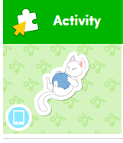  Practise the”wh” digraph. | Ten minutes - Number Bonds On Numbots  Activity:  On Espresso watch  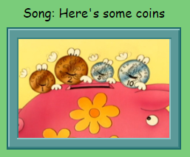  Have a go at playing this activity:  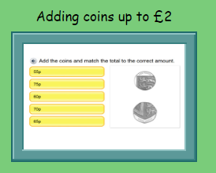 | PSHE  WAL:About how we can save energy.  On Espresso watch:  Geography/sustainability/my classroom  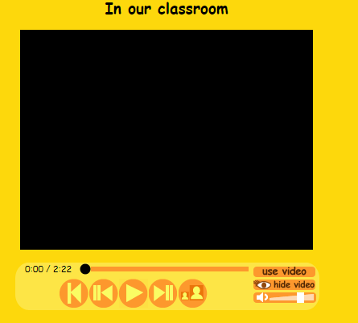  Have a look at the following activity:  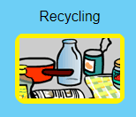  You could also look at the “How to be eco friendly” activities.

