Year 1 Home Learning Timetable Summer 2 Week 3

Day | Get Active at Home | English | Maths | Topic
Monday | 9am Joe Wicks Workout https://www.youtube.com/user/thebodycoach1  Mindfulness Children’s yoga videos www.youtube.com/user/CosmicKidsYoga | Reading - choose one of your reading books and read to an adult for 10 minutes OR log on to Oxford Owl and read some of the ebooks. Please create your own login!  Free eBook library  Activity:  Phonics - Espresso  - Home  - >  - English 1  - >  - Phonics  - >  - Scully's phonics  - >  - Activities  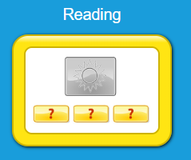 | Ten minutes - Number Bonds On Numbots  Activity:  WALT count to 100  Play  https://www.topmarks.co.uk/learning-to-count/helicopter-rescue  Select numbers 1-100 | Science  WALT name a variety of trees  Education City  “Naming Trees”  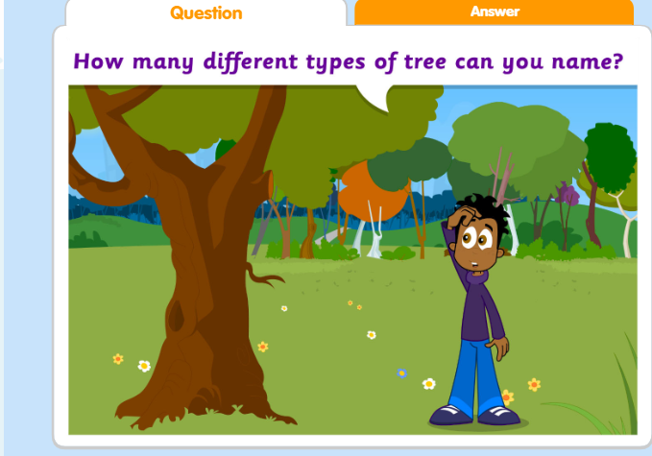
Tuesday |  | Reading - choose one of your reading books and read to an adult for 10 minutes  OR log on to Oxford Owl and read some of the ebooks.https://www.oxfordowl.co.uk/for-home/find-a-book/library-page/  Activity:  Phonics - Education City  “I cart believe it” Recognising and spelling CVC words  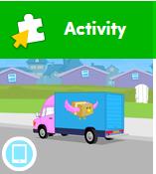 | Ten minutes - Number Bonds On Numbots  Activity:  WALT Compare numbers  Espresso  Maths1/Number and place value/ordering and comparing  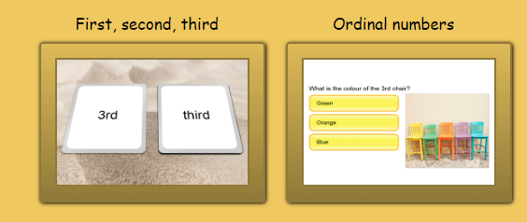  Have a go at these two activities. | Music  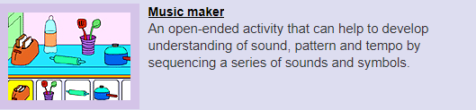  Espresso  Play “Music Maker”  Create different sounds, tempos and patterns by sequencing the sounds and symbols.
Wednesday |  | Reading - choose one of your reading books and read to an adult for 10 minutes  OR log on to Oxford Owl and read some of the ebooks.  https://www.oxfordowl.co.uk/for-home/find-a-book/library-page/  Activity:  Phonics - Espresso  Begin by watching this video:  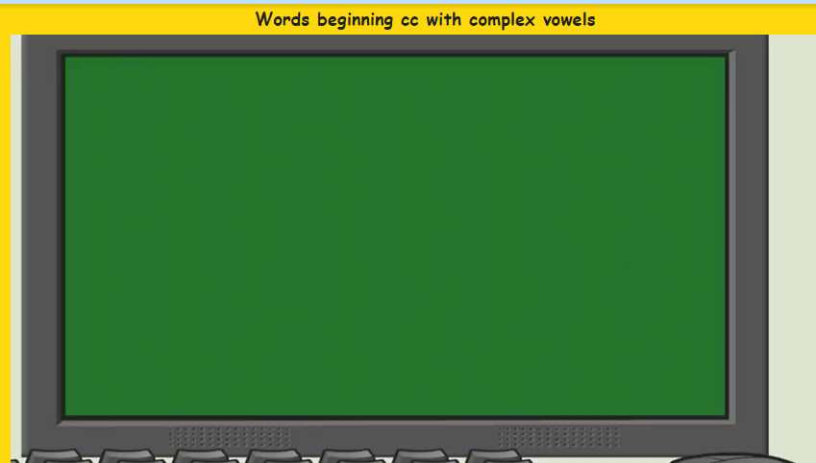  Then complete reading activity:  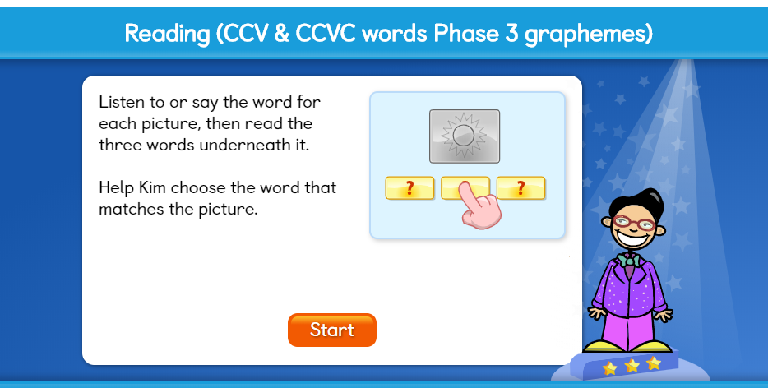 | Ten minutes - Times table rock Stars  Activity:  WALT to order numbers  Espresso  Maths1/Number and place value/ordering and comparing  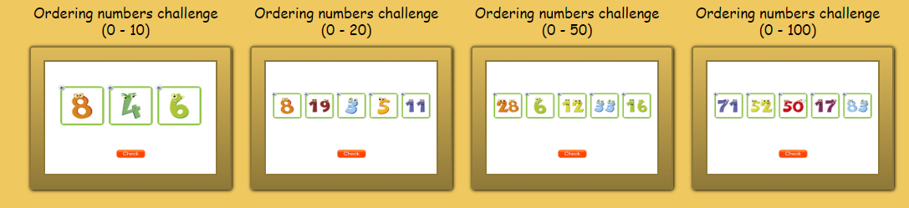  Start with ordering numbers 0-10. Then move on to ordering numbers 0-20. Can you challenge yourself to order numbers 0-50.  Ultimate challenge= order numbers 0-100 | Handwriting  Choose 5 tricky words. Can you practise spelling your words using the look, cover, write and check method.
Thursday |  | Reading - choose one of your reading books and read to an adult for 10 minutes  OR log on to Oxford Owl and read some of the ebooks.  https://www.oxfordowl.co.uk/for-home/find-a-book/library-page/  Activity:  Phonics -  Phonics - Education City:  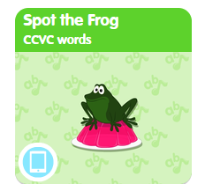 | Ten minutes - Times table rock Stars  Activity:  WALT to find one more or one less than a given number to 100  Education City “South Pole Snow”  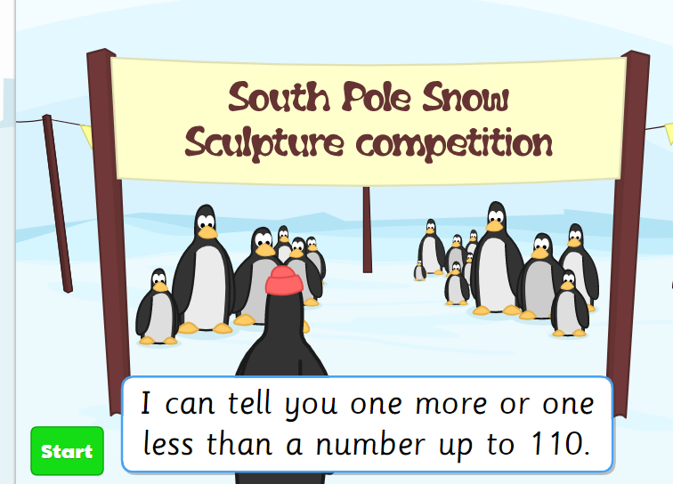 | ICT- coding  Unit 1b ‘Obey my command’  Lesson 1 Catch the Fish on Espresso coding (remember to log in to Google Chrome and link data first so that you don’t need to keep putting in your username and password each time).  Each step of the lesson has a help video for you to watch before you give it a go!  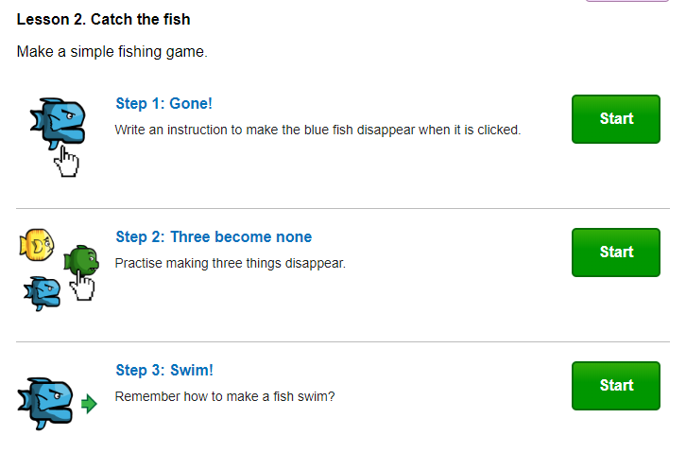
Friday |  | Reading - choose one of your reading books and read to an adult for 10 minutes  OR log on to Oxford Owl and read some of the ebooks.  https://www.oxfordowl.co.uk/for-home/find-a-book/library-page/  Activity:  Phonics -Espresso  Begin by watching this video:  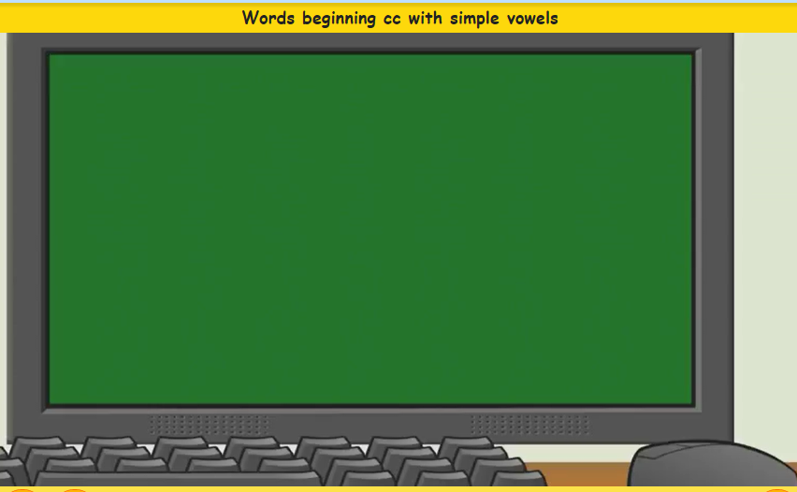  Then complete reading activity:  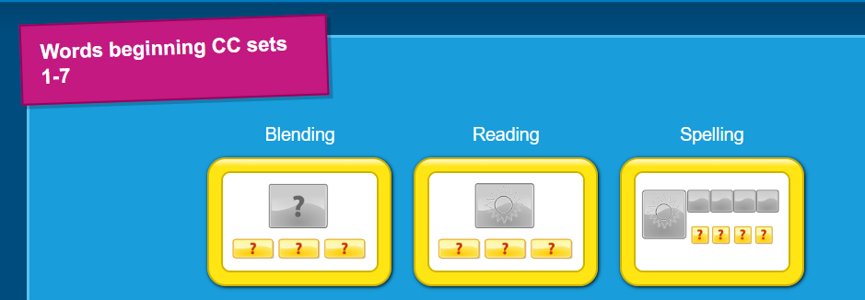 | Ten minutes - Number Bonds On Numbots  Activity:  WALT partition numbers  Espresso  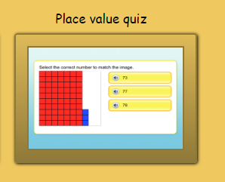 | PSHE  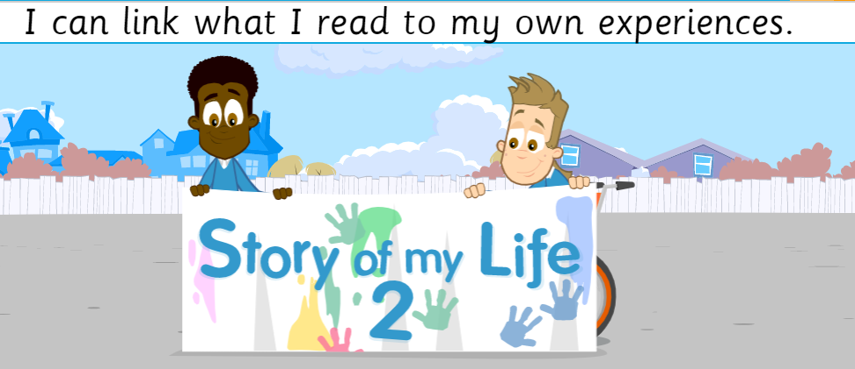  Education City “Story of my life 2”

