Year 1 Home Learning Timetable Summer 2 Week 2

Day | Get Active at Home | English | Maths | Topic
Monday | 9am Joe Wicks Workout https://www.youtube.com/user/thebodycoach1  Mindfulness Children’s yoga videos www.youtube.com/user/CosmicKidsYoga | Reading - choose one of your reading books and read to an adult for 10 minutes OR log on to Oxford Owl and read some of the ebooks. Please create your own login!  Free eBook library  Activity:  Phonics - Phase 5 Tricky Truck Words (phonics play) | Ten minutes - Number Bonds On Numbots  Activity:  WALT count to 100  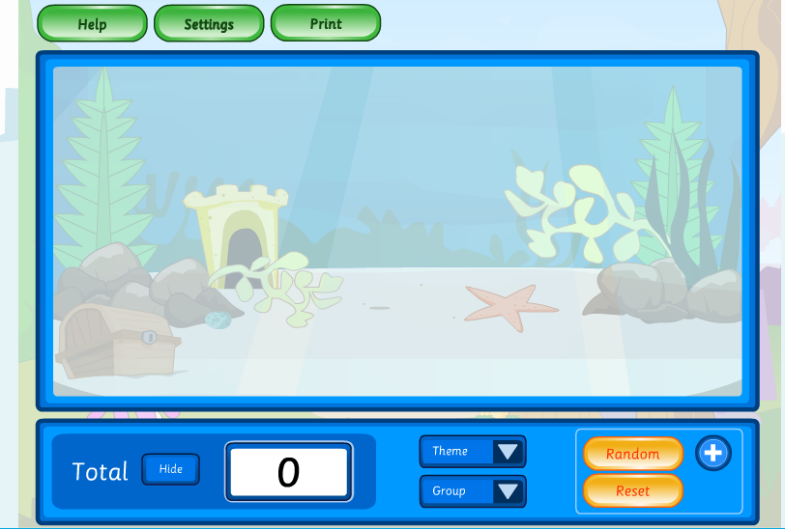  Education City -Counting up to 100 objects. | Science  Education City  Science/KS1/Year 1  Have a go at “plant parts” Can you identify all of the parts of the plant?  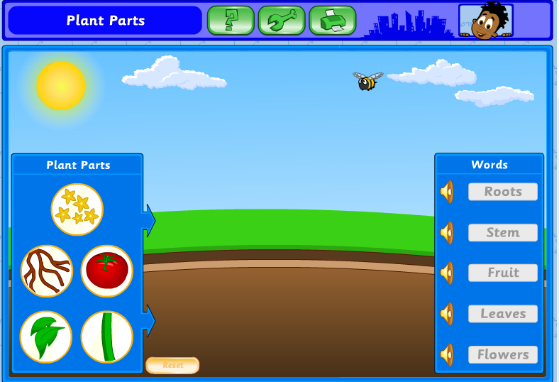
Tuesday |  | Reading - choose one of your reading books and read to an adult for 10 minutes  OR log on to Oxford Owl and read some of the ebooks.https://www.oxfordowl.co.uk/for-home/find-a-book/library-page/  Activity:  Phonics - Buried Treasure Phase 3-5 (phonics play) | Ten minutes - Number Bonds On Numbots  Activity:  WALT Partition numbers  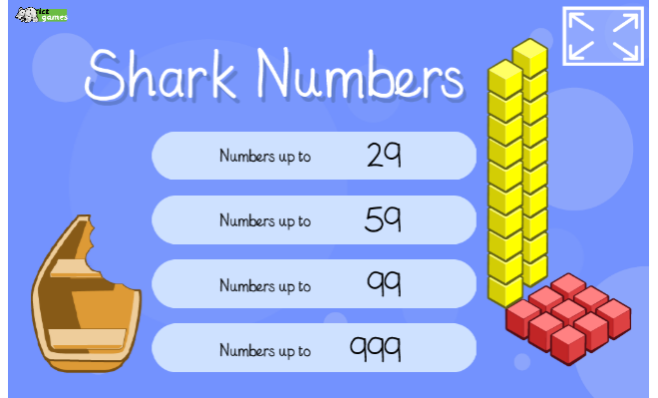  https://www.ictgames.com/sharkNumbers/mobile/index.html | Art  Go outside with paper, paint/ chalk/ pencils etc and create pictures from a story you have read recently. Think about shapes, colours, textures etc.
Wednesday |  | Reading - choose one of your reading books and read to an adult for 10 minutes  OR log on to Oxford Owl and read some of the ebooks.  https://www.oxfordowl.co.uk/for-home/find-a-book/library-page/  Activity:  Phonics - Think Chimp (CVCC words)  (Education City) | Ten minutes - Times table rock Stars  Activity:  WALT Partition numbers  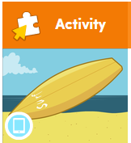  Play “Hang Tenths” on Education City | Handwriting  Choose 5 tricky words. Can you practise spelling your words using the look, cover, write and check method.
Thursday |  | Reading - choose one of your reading books and read to an adult for 10 minutes  OR log on to Oxford Owl and read some of the ebooks.  https://www.oxfordowl.co.uk/for-home/find-a-book/library-page/  Activity:  Phonics -Phonics - Espresso  - Home  - >  - English 1  - >  - Phonics  - >  - Scully's phonics  - >  - Activities  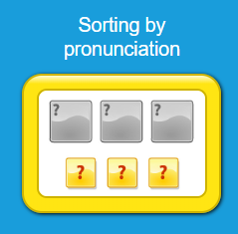 | Ten minutes - Times table rock Stars  Activity:  WALT Compare numbers  Espresso  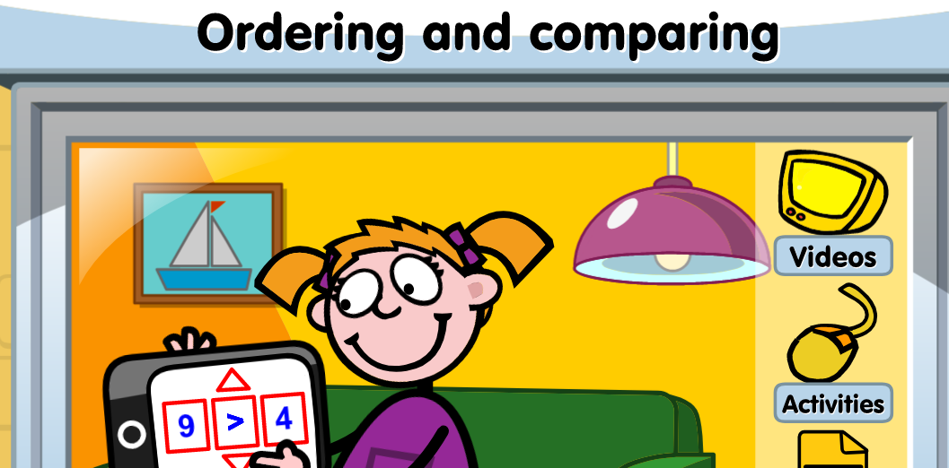  Watch  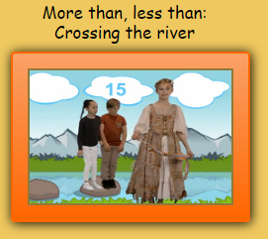  Have a go at playing  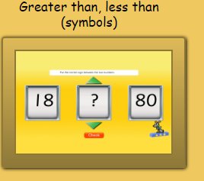 | ICT- coding  Unit 1b ‘Obey my command’  Lesson 1 Burst the bubbles on Espresso coding (remember to log in to Google Chrome and link data first so that you don’t need to keep putting in your username and password each time).  Each step of the lesson has a help video for you to watch before you give it a go!  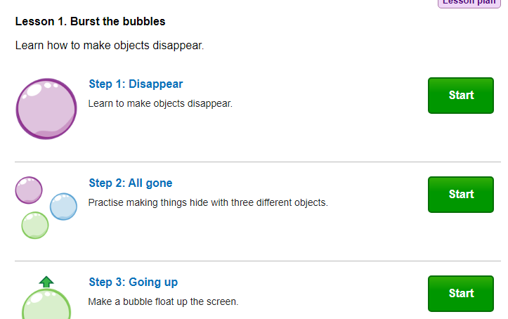
Friday |  | Reading - choose one of your reading books and read to an adult for 10 minutes  OR log on to Oxford Owl and read some of the ebooks.  https://www.oxfordowl.co.uk/for-home/find-a-book/library-page/  Activity:  Phonics -Sentence substitution (phonics play) | Ten minutes - Number Bonds On Numbots  Activity:  WALT Compare numbers  Play “Reel numbers” on Education city  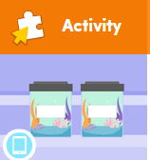 | PSHE  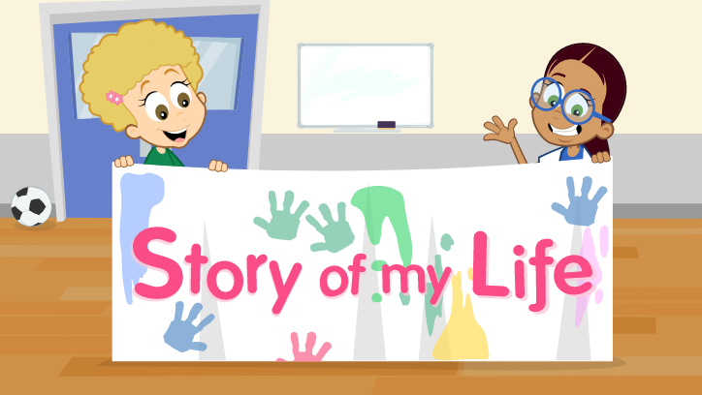  Education City “Story of my life”

