Year 1 Home Learning Timetable Summer 2 Week 1

Day | Get Active at Home | English | Maths | Topic
Monday | 9am Joe Wicks Workout https://www.youtube.com/user/thebodycoach1  Mindfulness Children’s yoga videos www.youtube.com/user/CosmicKidsYoga | Reading - choose one of your reading books and read to an adult for 10 minutes OR log on to Oxford Owl and read some of the ebooks. Please create your own login!  Free eBook library  Activity:  Phonics - Sentence substitution (phonics play) | Ten minutes - Number Bonds On Numbots  Activity:  WALT describe turns  Encourage your child to use the language ‘full’, ‘half’, ‘quarter’ and ‘three quarter’ to describe turns made by shapes/objects that you have around the house.  Children should be exposed to objects, shapes and themselves turning in different directions but do not need to describe the direction of the turns, e.g. left or right.  Mathematical talk:  What is each turn called?  Is there only one direction shapes/objects can move in?  How far has the shape/object turned?  What will the shape/object look like before or after the turn? | Science  What do you know about plants? Where have you seen plants growing? What do plants look like? Do all plants look the same? What are the similarities between plants? What are the differences between these plants?  Go outside and have a look at some plants and flowers.  Draw a plant/flower of your choice.
Tuesday |  | Reading - choose one of your reading books and read to an adult for 10 minutes  OR log on to Oxford Owl and read some of the ebooks.https://www.oxfordowl.co.uk/for-home/find-a-book/library-page/  Activity:  Phonics - Reading robots  (Phonics play) | Ten minutes - Number Bonds On Numbots  Activity:  WALT describe turns  On Espresso have a go at this activity.  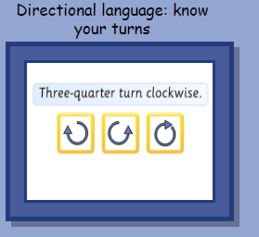 | Geography  On espresso watch  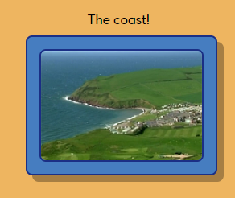  Complete the activity  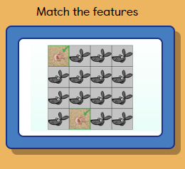
Wednesday |  | Reading - choose one of your reading books and read to an adult for 10 minutes  OR log on to Oxford Owl and read some of the ebooks.  https://www.oxfordowl.co.uk/for-home/find-a-book/library-page/  Activity:  Phonics - Think Chimp (CVCC words)  (Education City) | Ten minutes - Times table rock Stars  Activity:  WALT describe position  On Espresso watch….  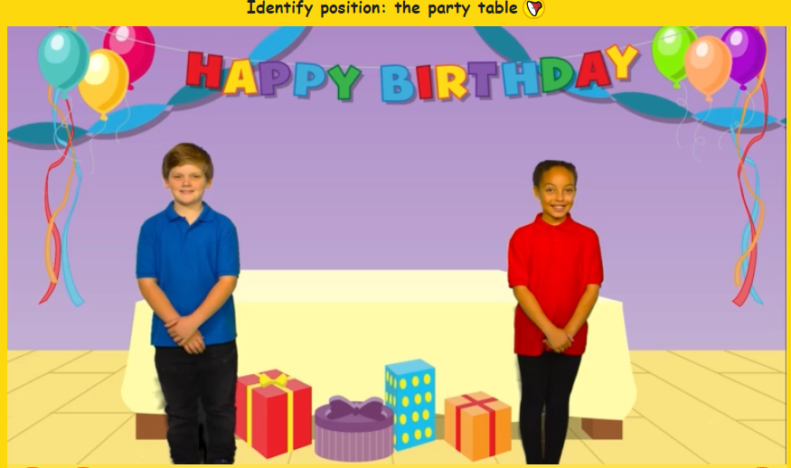  Have a go at completing these two activities.  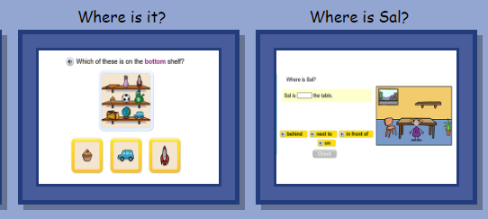 | Handwriting  Choose 5 tricky words. Can you practise spelling your words using the look, cover, write and check method.
Thursday |  | Reading - choose one of your reading books and read to an adult for 10 minutes  OR log on to Oxford Owl and read some of the ebooks.  https://www.oxfordowl.co.uk/for-home/find-a-book/library-page/  Activity:  Buried Treasure Phase 3-5 (phonics play) | Ten minutes - Times table rock Stars  Activity:  WALT describe position  Have a go on Education City playing the game “Going Overboard”  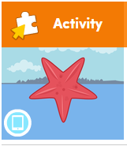 | ICT- coding  Unit 1a ‘On the move’  Lesson 6 Your own app (click) on Espresso coding (remember to log in to Google Chrome and link data first so that you don’t need to keep putting in your username and password each time).  Each step of the lesson has a help video for you to watch before you give it a go!  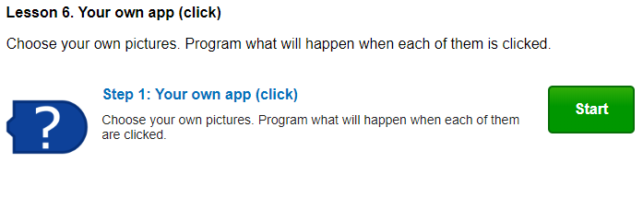
Friday |  | Reading - choose one of your reading books and read to an adult for 10 minutes  OR log on to Oxford Owl and read some of the ebooks.  https://www.oxfordowl.co.uk/for-home/find-a-book/library-page/  Activity:  Phonics - Phase 5 Tricky Truck Words  (phonics play) | Ten minutes - Number Bonds On Numbots  Activity:  WALT describe turns  On Education City, have a go at playing the “Photo Position Match” game.  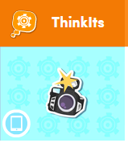 | PSHE  Get active with these traditional games which have been given an environmental twist  Ask children to do these actions when they hear the following words:  ■ Wildflowers- Run to the left edge of a playing space.  ■ Beehive- Run to the right edge of the playing space.  ■ Queen bee is coming- Bow and say ‘Your majesty’. (Explain that the Queen is the biggest bee in the hive. Her job is to lay eggs which will hatch larvae which grow to become bees. The colony will only survive if the Queen is cared for.)  ■ Queen bee has gone- Pull a silly face and stick out your tongue.  ■ Collect the nectar- Point arms down with hands together to form what looks like the bee’s proboscis (the tube through which they suck up nectar).  ■ Waggle dance- Do a dance on the spot. (Explain this move by stating that bees communicate where nectar can be found by doing dances that indicate the distance and direction of a food source.)  ■ Hungry larvae- Stand on the spot and open and close hands to mimic the movement of a jaw opening and closing.

