Year 1 Home Learning Timetable Summer 2 Week 6

Day | Get Active at Home | English | Maths | Topic
Monday | 9am Joe Wicks Workout https://www.youtube.com/user/thebodycoach1  Mindfulness Children’s yoga videos www.youtube.com/user/CosmicKidsYoga | Reading - choose one of your reading books and read to an adult for 10 minutes OR log on to Oxford Owl and read some of the ebooks. Please create your own login!  Free eBook library  Activity:  WALT spell the tricky words: little, one, do, when, what, out  Espresso-Scully’s phonics-Tricky words  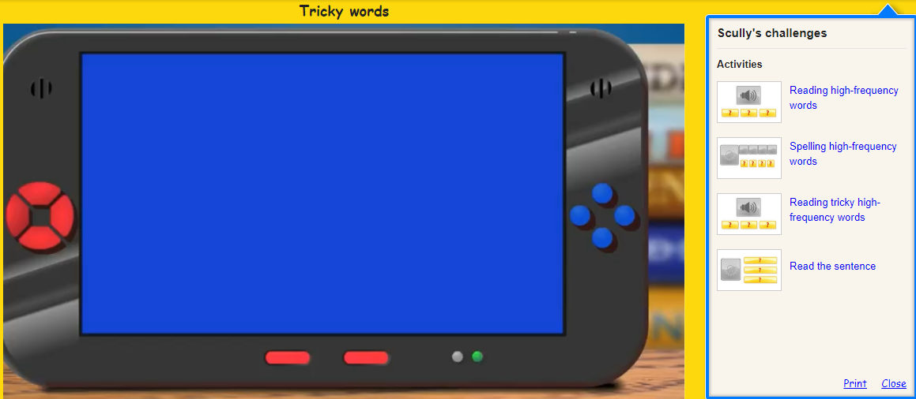 | Ten minutes -TTRS  Activity:  https://www.ictgames.com/sharkNumbers/mobile/index.html  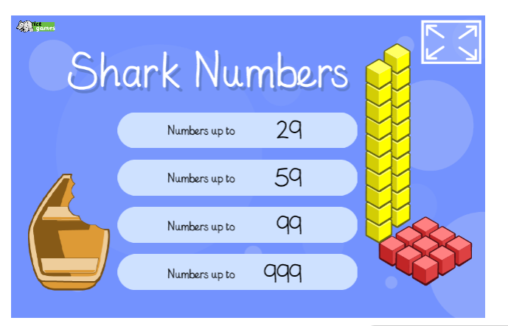 | Poetry  Education City/English/KS1  “Writing an acrostic name poem”  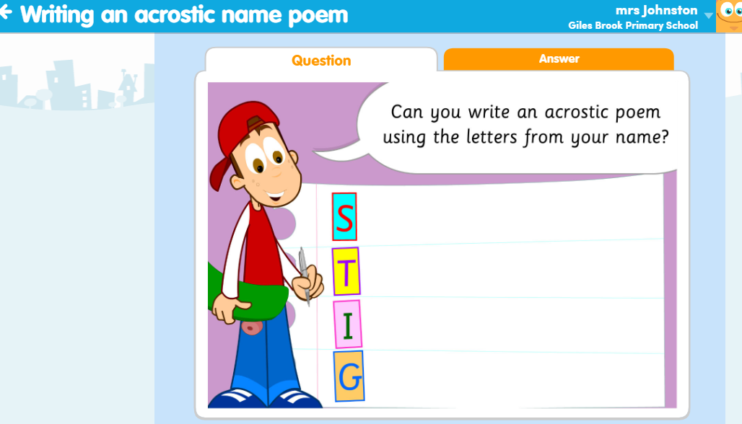  Have a go at writing an acrostic poem using the letters of your name.
Tuesday |  | Reading - choose one of your reading books and read to an adult for 10 minutes  OR log on to Oxford Owl and read some of the ebooks.https://www.oxfordowl.co.uk/for-home/find-a-book/library-page/  Activity:  WALT explore alternative pronunciation of the g and c graphemes  Espresso- Scully’s phonics, alternative pronunciations, g and c  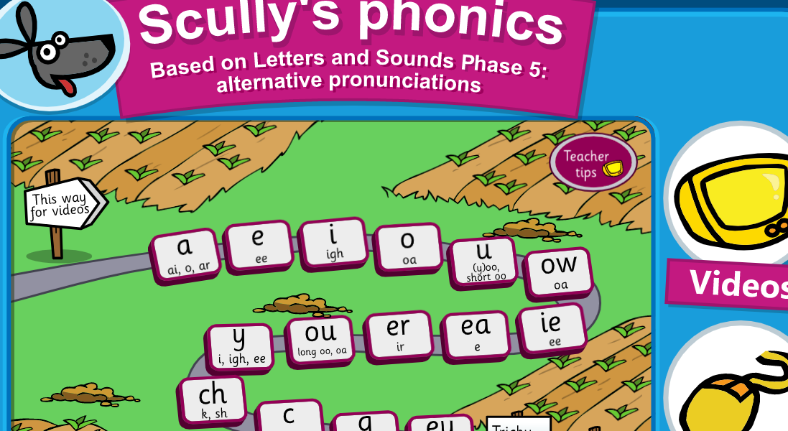 | Ten minutes - TTRS  Activity:  https://www.ictgames.com/mobilePage/lifeguards/index.html  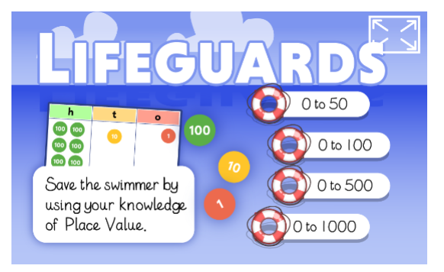 | Art  Read the story “The snail and the whale” If you do not have the book then there is a video from Christmas 2009 (on BBC iplayer and youtube)  Have a go at creating some puppets from the story. You can use anything you have around the house to create these. If you have any old socks, then sock puppets would be a great idea. Also if you have any lolly sticks you could also use these to make your puppet. See if you can retell the story using your puppets.  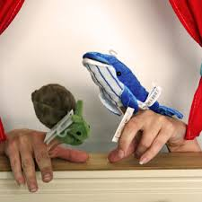
Wednesday |  | Reading - choose one of your reading books and read to an adult for 10 minutes  OR log on to Oxford Owl and read some of the ebooks.  https://www.oxfordowl.co.uk/for-home/find-a-book/library-page/  Activity:  WALT explore alternative pronunciation of the u grapheme  Espresso- Scully’s phonics, alternative pronunciations of u | Ten minutes - Times table rock Stars  Activity:  https://www.ictgames.com/mobilePage/playYourCardsRight/index.html  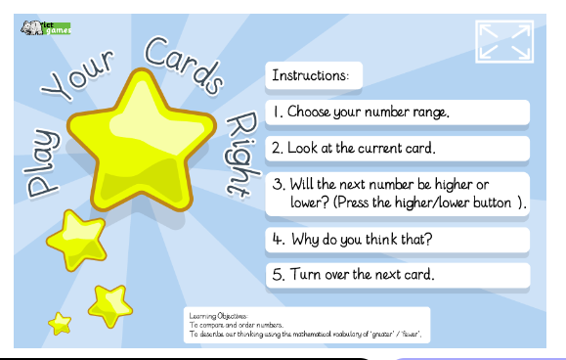 | Handwriting  Choose 5 tricky words. Can you practise spelling your words using the look, cover, write and check method.
Thursday |  | Reading - choose one of your reading books and read to an adult for 10 minutes  OR log on to Oxford Owl and read some of the ebooks.  https://www.oxfordowl.co.uk/for-home/find-a-book/library-page/  Activity:  WALT: explore alternative pronunciation of the ow grapheme  Espresso- Scully’s phonics, alternative pronunciations of OW | Ten minutes - Times table rock Stars  Activity:  https://www.ictgames.com/mobilePage/duckShoot/index.html  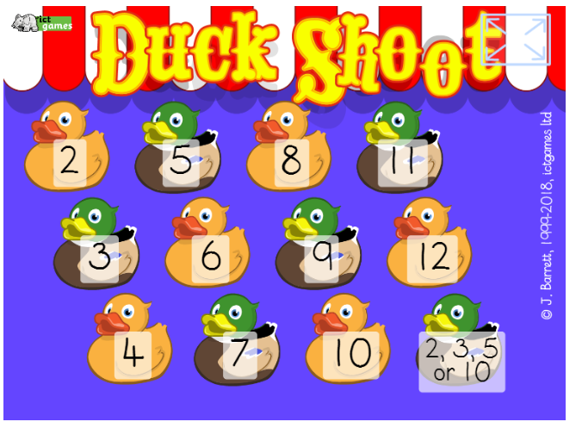 | ICT- coding  Unit 1b ‘Obey my command’  Lesson 6 My own app (add events) on Espresso coding (remember to log in to Google Chrome and link data first so that you don’t need to keep putting in your username and password each time).  Each step of the lesson has a help video for you to watch before you give it a go!  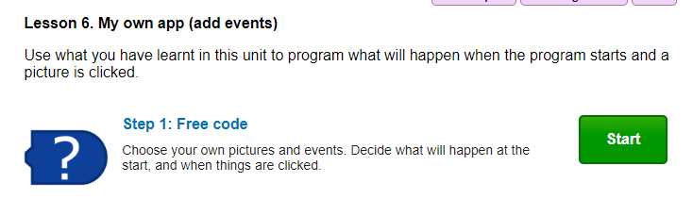
Friday |  | Reading - choose one of your reading books and read to an adult for 10 minutes  OR log on to Oxford Owl and read some of the ebooks.  https://www.oxfordowl.co.uk/for-home/find-a-book/library-page/  Activity:  Phonics -  WALT:explore alternative pronunciation of the ie grapheme  Espresso- Scully’s phonics, alternative pronunciations of OW | Ten minutes - TTRS  Activity:  https://www.ictgames.com/mobilePage/hundredHunt/  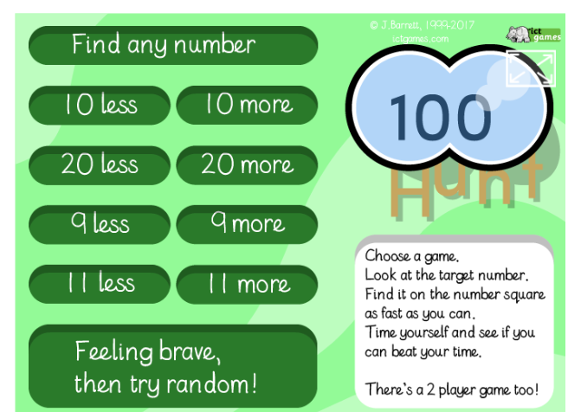 | PSHE  Have a think about moving into Year 2. Write a letter to your new teacher telling them all about yourself. Let them know what you are looking forward to in Year 2 and if you have any worries.

